- Avoid political parties and foreign affairs

- Strict – to follow the constitution word for word

Loose - is to be more open to interpretation
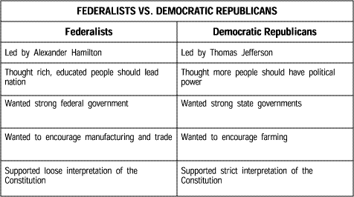

4. National Gazette – Republican
Gazette of the United States – Federalists

5. John Adams becomes the president
Thomas Jefferson becomes the vice-president

