Name: ____________________________ Date: _______________
Columbian Exchange
The Columbian Exchange was the widespread transfer of animals, plants, culture, human populations, technology, and ideas between the New World and the Old World in the 15th and 16th centuries, that was a result of Christopher Columbus’ voyages to America.
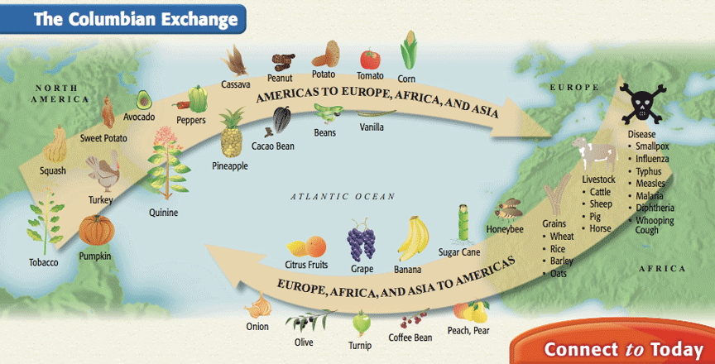
- List three (3) items that Columbus brought to the New World that positively affected the people there.
- Bananas
- Grapes
- Coffee beans
- List two (2) items that Columbus brought to the New World that negatively impacted the people there.
- Small pox
- Whooping cough
3. List three (3) items that Columbus brought back to the Old World that had a great impact on
the people there.
1. Pineapple
2. Turkey
3. Beans

