Name _____KEY_________
Date __________________
Period _________

The Iroquois
Stations Activity

Station 1:
The Iroquois Confederacy

Directions: Use the map puzzle to answer the questions that follow.

- Name the 5 tribes that made up the Iroquois.
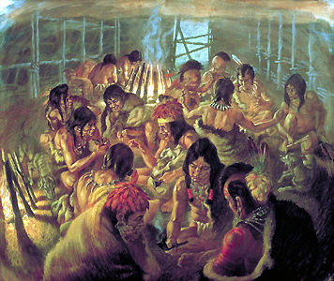
  - Mohawk

  - Oneida

  - Onondaga

  - Cayuga

  - Seneca

- What did the Confederacy form for the Iroquois?
(Look under the Seneca piece of the map)

It created a form of government

- There were 4 main goals for the Iroquois Confederacy. What were they?

  - Goal 1 (look under Cayuga piece): _____________________________

It created a peace between the tribes.

  - Goal 2 (look under Onondaga piece): ___________________________

The tribes agreed to trade with one another.

  - Goal 3 (look under Oneida piece): _____________________________

The tribes united and would go to war together against common
enemies.

  - Goal 4 (look under Mohawk piece): ____________________________

Sachems were elected by the tribes to represent them at the
council.
Station 2:
Food

Directions: Select one person from the group to read the AGRICULTURE paragraph, and another person to read the HUNTING paragraph. Make sure you listen to your group members while they read so that you can fill out the graphic organizer below.
  AGRICULTURE | 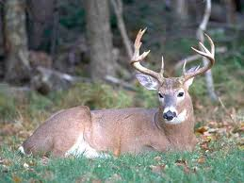  HUNTING
- What does agriculture mean?  Farming  - What were the Three Sisters?  Corn, beans, and squash  - Who was responsible for planting and harvesting the crops?  Women | - Who was responsible for hunting?  Men  - What kind of animals did the Iroquois hunt?  Dear, Black Bear, Passanger Pigeon, and Beaver  - Why do you think the Iroquois did most of their hunting during the fall and winter?  - They could not grow crops in the fall and winter and needed a food source.  - They needed animal skins to keep them warm  - They could not fish as much in the winter.
Station 3:
Shelter

Directions: Hit the play button on the Smart Board to watch the video and answer the questions that follow. The questions are in order of the video clip.

- What kind of houses did the Iroquois live in? Longhouses

- Approximately, how big were their houses? 150 to 250 feet long. Very big!

- What were the Iroquois shelters built out of? They used tree trunks to

construct poles and supports. They used tree bark for roofing.

- Describe what the family structure was like for the Iroquois in their houses? Who would live there?

The family structure was very large. It consisted of an extended family

which included grandparents, cousins, and other relatives. These

large families were called clans, and lived in the same longhouse.

- CRITICAL THINKING!

Explain how the Iroquois adapted their shelter to their environment.

The Iroquois used the resources in the Eastern Woodlands to build

Longhouses out of wood. They also made villages that were

protected by fences made out of wood.

_______________________________________________________
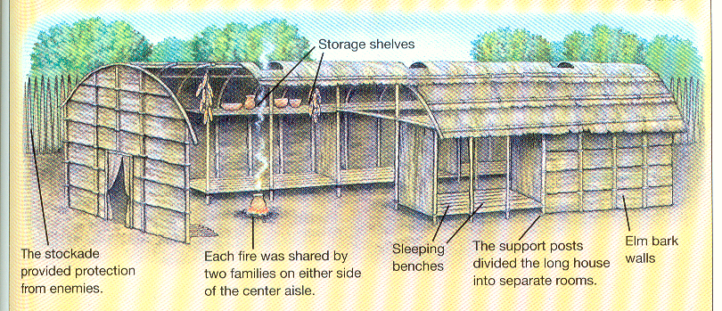
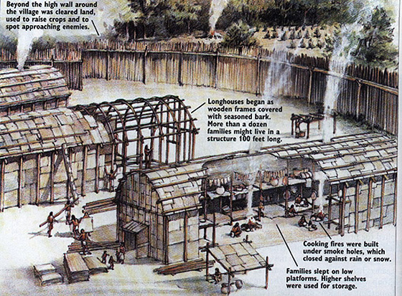

Station 4:
Village Life

Directions: Select one person from the group to read the WOMEN paragraph, and another person to read the MEN paragraph. Make sure you listen to your group members while they read so that you can fill out the graphic organizer below.
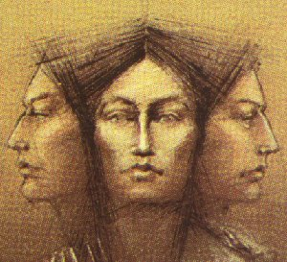  WOMEN | 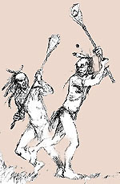  MEN
- What is a Matrilinial Society?  Ancestry is followed through the mother  It gave more equalite to women  - What was a Sachem?  An Iroquois chief that was a man  However, they were elected by women  - What household functions were women responsible for?  Preparing food, making clothing, and  caring for children | - What did men spend their time preparing for when they were not hunting?  warfare  - What did a man do after he got married?  Moved into his wife’s longhouse and  became part of her clan  - Why do you think Iroquoian villages were permenant?  Longhouses were difficult to move, and  they were fortified for defense.  They would only move if the soil  became unfertile.
SUMMARY

Directions: You have just completed four stations to learn about the Iroquois people. Use the information from each of the activities to complete the task below in at least 4 complete sentences.
Task: Explain the various ways in which the Iroquois adapted to living in the Eastern Woodlands.

___________________________________________________________
___________________________________________________________
___________________________________________________________
___________________________________________________________
___________________________________________________________
___________________________________________________________
___________________________________________________________
___________________________________________________________
___________________________________________________________
___________________________________________________________
___________________________________________________________
___________________________________________________________

